Academic Year: 2025-26 | Year: Second Year | Semester: II
PRN No.: 1012411011 | Name: Riddhee Kulkarni
Subject: Python Programming
Assignment No.: 3
Date: 22/12/2025

Lab Assignment: 03
Aim:
To write a Python program to calculate the distance between two points using their coordinates.

Objective:
- To understand the mathematical concept of calculating the distance between two points in a 2D coordinate system.
- To implement the distance formula using Python programming.
- To use the math module and its sqrt() function for mathematical calculations.
- To practice taking numerical input from the user and displaying the computed result accurately.

Theory:
The distance between two points (x1,y1) and (x2,y2) is calculated using the formula:
d = sqrt((x2 - x1)² + (y2 - y1)²)
Python provides the math module which contains the sqrt() function to calculate square roots.
The round() function is used to display the result up to a required number of decimal places.

Algorithm:
- Start the program.
- Import the math module.
- Input the coordinates of the first point (x1,y1).
- Input the coordinates of the second point (x2,y2).
- Apply the distance formula.
- Display the distance between the two points.
- Stop the program.

Pseudo Code:
START
IMPORT math
READ x1, y1
READ x2, y2
distance ← sqrt((x2 - x1)² + (y2 - y1)²)
DISPLAY distance
END

Code:
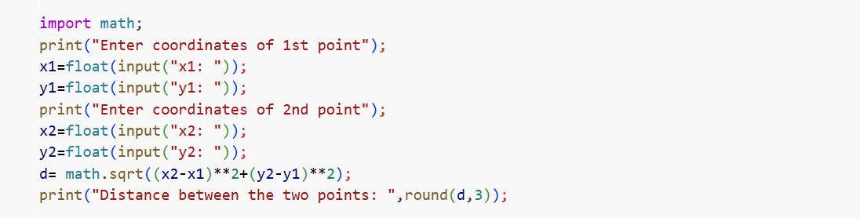

Output:
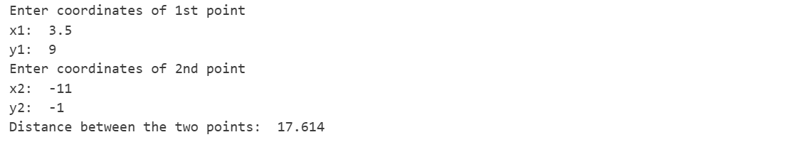

Conclusion:
The program successfully calculates the distance between two points using their coordinates by applying the distance formula and Python’s math module.

